DONATE APP

Aim:  
 To design a platform that simplifies the donation process for users, encouraging them to contribute to causes with ease while providing clear information about how their donations are utilized.

Procedure:

STEP 1: Create a new project with appropriately sized frames.

STEP 2: Establish background colors, grids, and guides for alignment.

STEP 3: Insert text, images, buttons, and icons.

STEP 4: Design form fields and set up interaction states.

STEP 5: Link frames for navigation and preview the prototype.

Prototype:

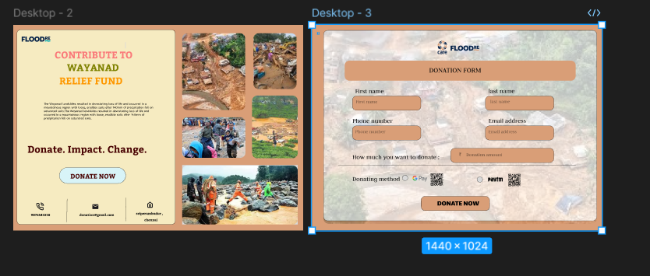

Result:  
 A visually compelling and easy-to-use app that facilitates donations, enhances user trust by providing transparency, and ultimately drives more contributions to charitable causes.